Fracking is the process of injecting liquid at high pressure into subterranean rocks in order to force open existing fissures and extract oil or gas. Like many oil/natural gas operations, fracking is a highly debated issue with one side saying the pros, such as creating jobs and gas prices going down, outweigh the cons, such as the pollution of nearby well water with the byproducts of fracking [1,5].

In the US, natural gas production has increased 35% from 2005 to 2013 and is expected to rise another 45% by 2040 [1,2]. Hydraulic fracking and horizontal drilling has largely been the cause of this increase [1]. Some problems associated with fracking and the drilling are contamination of local water sources and inducing earthquakes. Particularly, fracking has been known to cause earthquakes of magnitude 2 or less [3, 7]. Waste water disposal, however, has been known to cause more significant earthquakes[3,4,7] For example, an earthquake of a 5.6 magnitude that hit Oklahoma [3,7]. In fact, Oklahoma has been hit hardest in terms of increase of earthquakes due to high amounts of fracking and wastewater disposal [7]. Another issue with fracking is the amount of water it uses, and the limitations on fracking wells in areas with lower amounts of available water. Each fracking well uses between 2.7 and 3.5 million gallons of water[8]. This water is combined with various chemicals and fracking fluid, creating wastewater that needs to be treatment and disposal. And with much of the world’s water sources under pressure as it is, fracking increases this stress dramatically.

Our project’s dataset is a collection of various oil and gas operations. The dataset also includes the longitude and latitude coordinates of the wells so our first goal is to isolate the fracking wells from the other types and map out all of the well locations. From there we will compare the locations of the wells with a few other datasets, such as a dataset of earthquakes that have happened, a dataset of arsenic levels in groundwater or water wells, and datasets we can find on job/economic growth for areas where fracking operations are taking place. The goal of the comparison is to see how strong the correlations between fracking and earthquakes/water pollution, or economic stimulation are. We are also setting out to find a dataset on fracking accidents, or “fraccidents”, in order to set up a predictive model of any future “fraccidents” that could happen and/or what circumstances are shared among all the accidents, that could be avoided in the future to make fracking operations as safe as possible.

Now that fracking has become one of the popular alternatives to mining for coal and oil operations, its negative and positive effects both need to be weighed before it is declared as a long-term solution. While fracking could lead to a temporary economic boom in certain areas, if it has detrimental long-term effects on environmental stability then the public needs to know of these effects and determine if the economic boom would be worth the negatives. In order to make an informed decision, our project team will set out to produce both positive and negative correlations for fracking.

As we can see, fossil fuel extraction in the U.S. is a complex issue, and all types of extraction include both pros and cons with environmental and economic implications. In this project we are attempting to address the social need of people across the U.S. to be informed of these pros and cons, and provide insight into the problems that exist and how they might be solved. Hydraulic fracturing is often seen as a better alternative to other sources of fuel in regards to its environmental impact, although it is still a hotly debated issue, and the process of wastewater disposal is still a primary concern. We hope to be able to incorporate a wide variety of data together in order to better see the connections between various aspects of fracking that we have discussed and how they impact communities. Natural disasters and environmental degradation are important concerns for public health, while economic security and job opportunities are equally important for communities. We aim to present our data in a concise and visual manner so that the public can draw their own conclusions on the costs and benefits of fracking and make informed decisions towards the future.

Fracking and Injection wells, do they cause earthquakes and why? This is what we asked ourselves when beginning this project. Prior to this class the majority of us never knew what fracking and injections wells are and how widespread they are. The uniqueness of our question comes from the ignorance of society and our generation around the environmental impacts of such things. We found a government report from 1987, that was about research done on injection wells and fracking in the 60s-80s, so if the government knew of that fracking caused so many issues how is it that people aren’t made aware of these issues. Even in advanced placement environmental science class fracking was never brought up even though it is very widespread and causes a lot of issues.

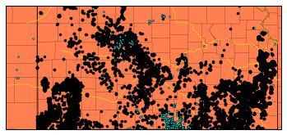On the topic of data and conclusions, there is an abundance of data on fracking, injection wells and other gas pump locations, earthquakes data is harder to find but is out there. We were able to find a database of a vast quantity of fracking, injection wells and gas pump locations in the United States, it contained information on the type of well, its latitude and longitude, the owner and state it was. It allowed us to form maps of the wells and overlay earthquake information on the maps. On this map of Kansas, the black dots are wells and the blue dots are major earthquakes of 3 or greater magnitudes. On the topic of earthquakes and fracking being related, there is a lot of debate online recently about the correlation between the two and there is a page on usgs.gov about induced earthquakes that explains most fracking wells are not the cause of induced earthquakes and it is instead injection wells. But a lot of these discussions and the usgs page does not correlate the issue directly to large increases in water pressure and the ability to mitigate the effects of the wells if we study the geological properties of the rock layers in the area. Through our research and the report Dillon found, we were able to infer that it would be feasible to have a government regulation that required a geological check of the rock layers to determine the amount of pressure allowed in well, so that we would be able to spread the various wells around so that we could reduce the risks caused by the wells. Also, we found that injection wells caused mainly micro-earthquakes of less than or around 1 magnitude. While not major, every earthquake gives a chance for a well to break and if we can reduce and minimize the earthquakes then we reduce well failure.

During our research Dillon found a paper report from the USGS from 1987 that talked about and explained deep well injection induced earthquakes, and the areas where induced earthquakes were prevalent [D2]. He also found a report by a geologist in Colorado about the Rocky Mountain Arsenal Disposal Well which was the disposal of dangerous leftovers from chemical warfare, which leaked into nearby groundwater which killed crops [D1]. The USGS report gave us detailed information on earthquakes in certain areas and the immediate increase in seismic activity after the instillation of injection wells in the areas. In the Colorado Rocky Mountain 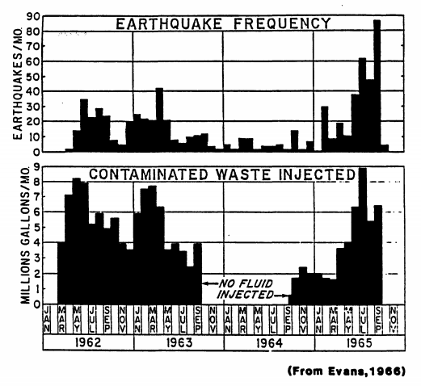Arsenal area, a total of 710 earthquakes were reported and a total of 620 million liters of water was injected into the well, increasing the fluid pressure in the area by a large amount. Through the research we found that it was often fluid pressure that was the defining factor in the cause of induced earthquakes. The USGS report detailed experiments done on some of the sites, one of which was the increasing and decreasing of fluid pressure in an area. It found that there were levels of fluid pressure that drastically increased seismicity and when low enough no earthquakes were detected in the area. The Mohr-Coulomb failure criterion, which is used to determine the strength and resilience of things such as rock formation, concrete and asphalt, could be determined the geological survey of the area at the bottom of the wells. This gives reason to our proposed government regulation that introduces geological surveying of areas around fracking and injection sites. A topic discussed in detail that we considered heavily was the Mohr-Coulomb theory, when looking over the earthquake reports we spoke of our idea of government regulation, and while looking through the rest of the paper we came to find that it also discussed a similar idea, of monitoring the strength of the rock formation around the well location and at the depth of the well, and to monitor fault lines and amount of friction. A usual earthquake occurs when the shear stress over comes the shear strength and frictional stress on a plane, which causes a slip or earthquake [D2]. When wells are drilled into the ground and rock layers it causes decreased shear strength which increases the chance of slips, with fluid pressure it causes a decrease of strength and increase on stress which is why injection cause far more earthquakes than with just fracking.

Injection wells are used to place unwanted fluids deep underground into permeable rock formations. There are many uses for injection wells including disposing of waste, storing gases, and disposing of salt water that arises as a byproduct of oil production. Some of this wastewater is produced by the process of fracking, which involves pumping millions of gallons of water deep underground to open fissures and extract the gas or oil from those fissures. Although some of this water will remain deep underground within the fissures, some of it will also come back to the surface as “flowback” [K1] that must be dealt with. Some oil companies will reuse a lot of this wastewater such as Marcellus Shale production, out of Pennsylvania, that reuse up to 87 percent of their flowback or wastewater generated [K1]. While fracking produces a certain amount of wastewater, most of the wastewater produced comes from the deposits of oil and gas themselves. These deposits often contain sizable amounts of salt water that arises when the oil or gas is removed from its deposit. While it is possible to treat this water, and reuse it like the flowback, most of the water ends up being pumped deep into injection wells. When this water is pumped into the injection wells it can pry apart the tectonic plates by opposing the frictional force that the plates usually sustain.

In recent years, amidst the fracking boom in the Midwest and California where the number of injection wells grew by twice as many, scientists have been searching for the link between injection wells and earthquakes. Most scientific studies link the rise in earthquakes in the Oklahoma region with the injection of wastewater into deep underground wells. Despite this, the U.S. Geological Survey has stated that “only a small fraction of these disposal wells have induced earthquakes that are large enough to be of concern to the public” [K2]. The important question to take away from this quote is what the USGS would define as an earthquake large enough to concern the public. The reason this is noteworthy is that in the Midwest the number of earthquakes that they face per year has grown exponentially in the past four years. In Kansas, before 2013 they had only experienced 40 earthquakes, with 6 of those being greater than magnitude 3.5, but since the start of 2013 they have experienced 2,190 earthquakes with 89 of those being of magnitude greater than 3.5. While magnitude 3.5 earthquakes are not the greatest feat, they can still be felt [K3] and there is still a very noticeable increase in seismicity in Kansas. Once again in Kansas, before 2013 they had only experienced 1 magnitude 4.0 or greater earthquake, which per the USGS can be felt indoors by many with walls, windows, and doors being disturbed [K3], while after the start of 2013 they have experienced 15 of said earthquakes. In the eastern region of Oklahoma, before 2013 they had only experienced 483 earthquakes, with 9 of those being of magnitude greater than 4.0, while after the start of 2013 they have had 7,053 earthquakes with 49 of those being of magnitude greater than 4.0. There could be many causes for this increased seismicity, but our group is looking for a correlation, if it exists, between earthquakes in the Midwest and injection wells by using machine learning to map out a k-cluster of earthquakes on a map of the wells in the area.

Our project sets out to create a k-means cluster of the earthquakes on the map of the wells to show the correlations that exist. To do this, we first had to find the earthquakes data. Keegan found a search tool from the USGS Earthquake Hazards Program that would take parameters such as location, magnitude of the earthquake, and how far back to get data for and output a CSV of the earthquakes that occurred within the parameters. For our purposes, Keegan searched through the conterminous United States for earthquakes of magnitude 2.5 or greater that can at least cause minor damage dating back to 1980. Once he had obtained the dataset, he cleaned it up by deleting any of the columns that contained useless info such as status, type, id, and net among others. This cleaning up of the data was useful because all we needed to map out the earthquakes was the time, latitude, longitude, and magnitude of the earthquake. Then, he created a simple python program to read in the CSV and arrange each of the columns into its own list i.e. time, latitude, longitude, and magnitude lists. The goal of the program was for the earthquakes data to easily be implemented with the wells data for a k-means cluster. Furthering the work on the program, he also created a simple search tool that will print out the number of earthquakes in the dataset before and after a certain time. He also implemented another search tool that will search for earthquakes that had a magnitude larger than a given magnitude for before and after a specific year. The reason for this was that we can now see how many more earthquakes have happened in recent years than have happened in the past 30 years. There is without a doubt something that has disturbed the earth beneath Kansas and some other Midwestern states and it does appear to coincide with the fracking boom in recent years. In the future, people should continue to monitor the number of earthquakes and the fracking presence in Midwestern states.

For the two maps below, we used the search tool from the USGS to map out the earthquakes in Kansas before 2013 (the first map) and after the start of 2013 (the second map) [K4].

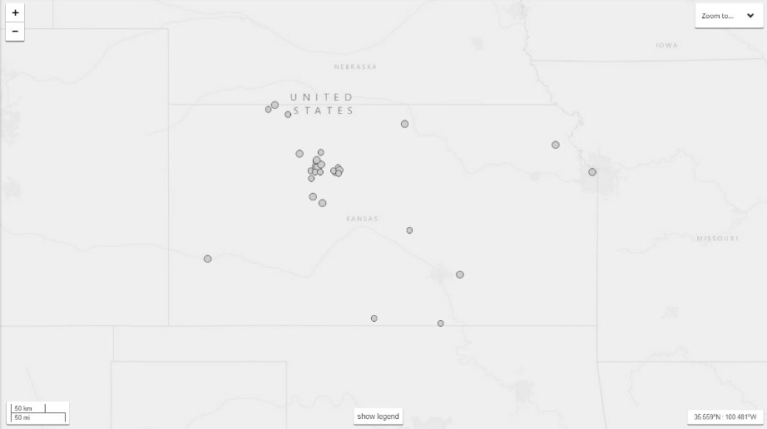

The first task we did in the clean-up of the ogs-oilandgas-well-locations.xlsx file was to separate GAS, GIW (gas injection well), WIW (water injection well), and BDW (brine disposal well) into different excel sheets for easier manipulation. We uploaded the file to the GitHub repository, but we realized some column titles were left out on some of the well types, which we promptly fixed. Some issues with the data itself was the location coordinates. There were two sets, one labeled “BH…” and the other labeled with “Wh…” or “WH…”. The “BH…” label turns out to most likely stand for bottom hole, but we still have no clue what Wh stands for. We ended up just getting rid of the “BH…” coordinates altogether because both coordinate labels were very close in value with each other, and most were identical.

One of our crew members found another data set containing possible all the wells in fifty states of the United States of America. This data set had to be split into seven csv files in order to fit onto GitHub. The files were named with this format: “wellsX.csv” where X was a number from one to seven. Three of the 7 file names were saved incorrectly at first, “wells5”, “wells6”, and “wells7” were spelled with capital “W”. We fixed that before working on cleaning up the data. The data was pretty much a mess. All the csv files had the same column titles, but each state had different phrasing for the type of wells and how the columns were filled out. Before we tackled getting most of the types to be phrased the same way, we got rid of some of the columns. We decided to remove two columns, “spud date”, and “API” column. For many of the data entrees, “spud date” was blank, so we decided that we shouldn’t use it. The “API” column we got rid of because we didn’t really need to know the unique identifying number of each of the wells, we were just interested in the locations of the wells.

For wells1 and wells2, we started getting rid of the entrees that didn’t have a type filled out. We stopped doing that once we realized some of the states used the “status” columns to label what type of well it was. Also, we could still use wells without a type, we would just have to label in either unknown or other type of well. We also decided to keep wells that were labeled abandoned in the “status” columns because abandoned wells were still dangerous to environment.

The main issue for cleaning up the data was to figure out what phrasing the states were using to describe the wells. At first we decided to use python to grab all the types and count them with a default dictionary, like we did with frequency calculations of articles. We were going to make a list of ones we combined. But what we ended up just doing, was to go through each of the csv files in excel and find what they used. We changed entrees that had types such as “OIL”, “oil”, “OIL WELL” or “Oil Well” to just “Oil Well”. Gas type wells were changed to “Gas Well”. To change these, we made use of the find and replace function in excel. Wells for disposing of salt water were labeled as “Brine Disposal Well”. Many were either labeled as “SWS”, “Salt Water”, et cet. Injection wells were either labeled as “Injection Well”, or “Water Injection Well”. We kept track of as many types as we could in a separate text file for referencing. For the states that used the status column as describing the well type, we manually moved the sections into the “type” column. We needed to clean up some of the types to easily pull them from the csv files into python for our map. We did not want to have 6 or 7 different things to search for, when we specifically wanted oil wells or gas wells.

One thing we realized we may need is the spud date. Not all states have them, so we will end up focusing on one particular state for this data.

Also, OK and TX were not showing up on the map we initially created. We were able to get OK on it once we changed our for-loop to include our final wells, wells7.csv, since it was not being read into it. TX was not in original data set and it apparently costs to get the data so we are letting TX bite the dust.

One of the things Ryan has been considering is using k means clustering or a similar argument to find some average points to represent many wells in a particular state. I was looking on some forums, and some of them pointed out k means clustering wasn’t good for distances with latitude and longitude. K means sort of worked, in the sense it gave some of those points, but I have been attempting to use DBSCAN, Ward’s Hierarchal Clustering, and mean shift ML techniques. These techniques are available on sklearn. DBSCAN and Ward’s Hierarchal Clustering both ended up crashing my laptop when using the full data set I have for Kansas. I eventually got DBSCAN to work and visually displayed it with the help of example code on sklearn. However, DBSCAN did not separate the wells into reasonable groups. Basically, it either had one cluster, which was the entirety of the wells, or had several clusters, where one was most of the wells. I believe this isn’t going to work because DBSCAN usually goes by finding groups that are grouped by different whitespace, which the wells are very dense.

We decided to focus on one state; this was to cut down on the amount of data we use in our programs. The first thing I (Ryan) did was to get all the Kansas data from the set that had spud date data into a separate csv file. In python, I separated the wells that had type of Oil Well, Gas Well, Brine Disposal Well, and Injection Well into separate lists of coordinate pair lists. I also made a list with all the wells.

During the early phase of the project, we threw around ideas about what programs we could code that would give us a better understanding of the data. We began with the idea of simply mapping the locations of all the wells in the wells1-wells7.csv files (we will refer to these as the singular wells dataset). The program that Jonathan wrote to accomplish this goal was a simple and straightforward starting point for what we could later expand on. This starting point of the project code consisted of a scatterplot with points representing wells mapped by their latitude and longitude coordinates. From this, we could make general observations regarding the general spread and shapes that the points created, leading us to the realization that our latitude and longitude were backwards, so we switched them and could then see that the data showed a distinguishable outline of the United States.

After learning what we could from the data in this form, we decided to improve the results of the code to give us a better visualization that included more context. Jonathan then implemented a solution using the basemap toolkit for python (Visualization) (). Using this, he was then able to map the points on the United States, complete with the context of a map (see fig. 1). With this more useful visualization, we could distinguish areas where we could focus our attention and look for any patterns. Then, to further the functionality of the visualization, we added earthquake location data found by Keegan. However, due to limitations of the source, we were unable to pull earthquake data for the entire country. So, we considered the possibility of narrowing our scope to specific areas of the country. This would allow us to pull smaller chunks of location data for earthquakes and still analyze them alongside the well location data. 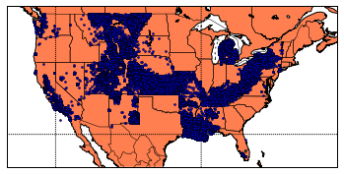

Figure 1 (blue dots are wells)

Upon mapping the wells in the United States, we made an unfortunate discovery; Texas had no wells in it, and neither did Oklahoma. There were other states for which the data was missing; however, most of the states lacking data are outside the region on which we are focusing. We discovered that the data for Texas was not in the dataset at all, which made no sense because the article which cited the dataset, presented conclusions based on data from Texas. To make matters worse, the Oklahoma data – though present in the dataset – was not visible on the map we had made. This was later resolved as Ryan discovered an error in Jonathan’s algorithm that was keeping it from reading the data contained in wells7.csv.

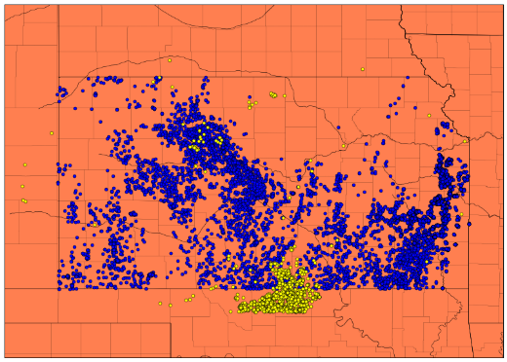 Upon considering the aforementioned issues we encountered, we decided to limit the scope of the project to a less broad area. Doing this allowed us to cut down the amount of data needed, and it enabled us to move forward in the project. Our focus was then narrowed down to Kansas.

So, Keegan pulled earthquake data specifically for Kansas, and Jonathan adjusted the code to plot the earthquake data in conjunction with the wells data for the same area. Additionally, the changes to the code filtered out wells which aren’t being used for fracking or wastewater disposal (see fig.2).

Figure 2 (blue dots are wells, and yellow dots are earthquakes)

With the data sufficiently focused, Jonathan could implement more useful features into the code that would allow us to investigate the data further. The most useful of these was the ability to set time windows for earthquake occurrences and spud dates (the point at which drilling the well begins) for the wells (fig. 3). This feature allowed us a more coherent way to observe correlations between the positioning and timing of both earthquakes and fracking wells.

Unfortunately, we ran into an issue regarding this approach; though we have the Oklahoma data, that data does not contain spud date information. Therefore, we would be unable use the data in an effective way that would assist in us reaching any conclusions regarding it. This is another reason we decided to focus particularly on Kansas; the data is rich with useful features that would then allow us to draw more helpful insights from it.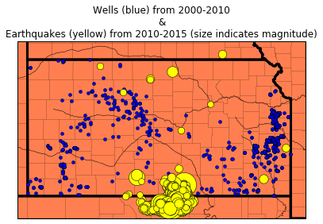

Regarding the data source, there are some inconsistencies between what the article (Kelso) states and what is present in the data (which our project is based on) referenced. The article includes observations based upon wells data for Texas. The issue is that the wells dataset does not include Texas wells data. Upon further research, Ryan found that the wells data for Texas is excluded from the wells dataset because it is only available for a cost. This is another factor which led to our decision to limit the scope of the project to the areas for which we have rich data.

Figure 3

In this project, we analyzed the impacts of several effects of fracking on geography and potential environmental hazards. For our project we have completed several tasks, including performing background research, finding and gathering datasets, and performing data analysis and visualization using techniques coding in Python. Will was able to locate the ideal source for earthquake datasets from the USGS website so that we would have access to data of locations of earthquakes of all magnitudes in the United States for the designated time frames. Using the USGS earthquake data search tool, it is possible to gather specific data on known earthquakes. We were able to specify the parameters for our data in order to include only the geographic areas we needed, within the United States, as well as min and max magnitude, the time frame of dates included, and number of entries collected (number of data points per data download). From here we were able to clean up the data and extract all of the relevant fields of information that we needed in order to do a data analysis and plot out the locations using Python.

Collecting all of this data on earthquakes, fracking, and wastewater injection wells allowed us to do a fair amount of data analysis and visualization on the effects of fracking. We were most interested on this topic in order to provide us information that can apply to a societal need, here specifically we were focused on human safety and security. Namely, we were concerned with the effects of the processes of fracking on the environment and subsequent effects on human health in communities nearby to incidences of fracking and wastewater injection disposal. The increase in earthquakes can be correlated in specific instances to areas with high concentrations of injection wells. Our data does not always necessarily show incidences of large earthquakes directly on top of well sites, but rather an overall increase in larger surrounding areas. The impacts of geological fault lines are typically more widespread, and require that we look from a wider scope. A pressurized injection may also not necessarily cause earthquakes right away, so it could be valuable to look at earthquakes versus injections on a longer timeline type basis.

We desired to do an analysis so that we could split up our results into different time frames so that we could perceived changes over time and the progression of effects over different time periods. When doing an analysis of k-means clustering, we chose to also divide up our data based on multiple time frames and do a machine learning analysis from there to determine similarities and differences between the different groups of locations of wells across different time frames. Ryan and Will worked on aspects of this coding and collecting all of the well data together so that it could be used efficiently.

To provide some more of the background to our project and the societal and environmental issues that it addresses, we wanted to do a lot of research into the processes of fracking and its potential effects. Aside from the possibility of increasing frequencies or strength of earthquakes, one of the main issues that we were concerned with was the effects of fracking on water quality. The process of fracking involves the use of several types of chemicals, most of which by law are not required to be disclosed by the companies performing the fracking operations, and therefore the initial chemicals used are impossible to do any kind of analysis of.

We are more concerned with the wastewater injection wells, and how these injections may affect the quality of water found in groundwater sources that may be drawn up and used for drinking water to towns and cities. It is possible that injections of wastewater into the ground can have a leaching effect, where chemicals can get into groundwater and eventually into the water stream of human communities’ drinking water. Many reports have shown connections between fracking and the poisoning of local water. We were very concerned with this issue, although actual hard data sources on the subject were difficult to find. We investigated several sources of water quality data, but none of which contained information on the specific chemicals that we were interested in that could possibly be linked to fracking operations.

[D1] Evans, David M. “The Denver Area Earthquakes and the Rocky Mountain Arsenal Disposal Well.” *Engineering Seismology*, pp. 25–32., doi:10.1130/eng-case-8.25.

[D2] Wesson, Robert, and Craig Nicholson. “EARTHQUAKE HAZARD ASSOCIATED WITH DEEP WELL INJECTION.” *US Geological Survey*, June 1987.

1. R. J. Pierce Jr, *Natural gas fracking addresses all of our major problems*, Geo. Wash. J. Energy & Envtl. L. **4** (2013), 22.

2. D. C. DiGiulio and R. B. Jackson, *Impact to underground sources of drinking water and domestic wells from production well stimulation and completion practices in the pavillion, wyoming, field*, Environmental Science & Technology **50** (2016), no. 8, 4524-4536.

3. W. L. Ellsworth, *Injection-induced earthquakes*, Science **341** (2013), no. 6142.

4. R. A. Kerr, *Learning how to not make your own earthquakes*, Science **335** (2012), no. 6075, 1436-1437.

5. J. E. Johnston, E. Werder and D. Sebastian, *Wastewater disposal wells, fracking, and environmental injustice in southern texas*, American Journal of Public Health **106** (2016), no. 3, 550-556.

6. Q. Meng, *The impacts of fracking on the environment: A total environmental study paradigm*, Science of The Total Environment **580** (2017), 953-957.

7.         K. M. Keranen, M. Weingarten, G. A. Abers, B. A. Bekins and S. Ge, *Sharp increase in central oklahoma seismicity since 2008 induced by massive wastewater injection*, Science **345** (2014), no. 6195, 448-451.

8. B. K. Sovacool, *Cornucopia or curse? Reviewing the costs and benefits of shale gas hydraulic fracturing (fracking)*, Renewable and Sustainable Energy Reviews **37** (2014), 249-264.

K1. “Underground Wastewater Disposal.” *Energy In Depth*, Independent Petroleum Association of America, 2015, www.bing.com/cr?IG=41FA70CCFE1D4BD6B5A1EF1610ED3E26&CID=3066B8B6E5A960873E22B2C4E439615E&rd=1&h=B5IZmza1AFGeDBWnD7T1AnhyBMdGT2n_4B7qtHQSiag&v=1&r=https%3a%2f%2fenergyindepth.org%2fwp-content%2fuploads%2f2015%2f02%2fWastewater-Disposal-Q-and-A1.pdf&p=DevEx,5060.1. Accessed 25 Apr. 2017

K2. “USGS FAQs- Earthquakes Induced by Fluid Injection.” *USGS FAQs - Earthquakes Induced by Fluid Injection - Do All Wastewater Disposal Wells Induce Earthquakes?*, U.S. Geological Survey, www2.usgs.gov/faq/categories/9833/3424_home. Accessed 27 Apr. 2017.

K3. “Magnitude / Intensity Comparison.” *U.S. Geological Survey*, U.S. Geological Survey, earthquake.usgs.gov/learn/topics/mag_vs_int.php. Accessed 28 Apr. 2017.

K4. “Search Earthquake Catalog.” *U.S. Geological Survey*, U.S. Geological Survey, earthquake.usgs.gov/earthquakes/search/. Accessed 28 Apr. 2017.

Kelso, BA Matt. "1.7 Million Wells in the U.S. - A 2015 Update." FracTracker Alliance. Foundation for Pennsylvania Watersheds, 24 Apr. 2017. Web. 28 Apr. 2017.

“Visualization: Mapping Global Earthquake Activity.” *Introtopython.org*, *Introtopython.org*, introtopython.org/visualization_earthquakes.html.

cjgohlke, dsdale, efiring, heeres, et al. “Matplotlib.” *Browse /Matplotlib-Toolkits/Basemap-1.0.7 at SourceForge.Net*, sourceforge.net/projects/matplotlib/files/matplotlib-toolkits/basemap-1.0.7/. Accessed 28 Apr. 2017.